November 13, 2023

Dominik Subocz

HND SOFTWARE DEV (YEAR 2)

DESIGN DOCUMENT

COIN FLIP APP

Contents

Overview of the user interface design 2

Design principles 2

Navigation and menu structure 2

Visual elements and branding 2

Designs 3

Interaction Design 4

# Overview of the user interface design

The Coin Flip’s UI design isn’t very complex, it also isn’t too professional, it probably has some faults here and there, but I think it’s not too bad. While it may look quite bad, it’s quite easy to use.

This section provides a comprehensive overview of the design principles, layout and interactive elements that shape the visual identity of the application.

# Design principles

The user interface design prioritises a visually appealing, minimalist, and user-friendly experience.

Although some design guidelines were considered during development, the focus is on achieving a modern, elegant look that is consistent with the concept of simplicity in the application.

The design aims for an intuitive layout, focusing on clarity and efficiency, meeting the needs of users who appreciate a clean and simple aesthetic.

The final user interface reflects the deliberate choice of a distinctive and stylish design, moving away from strict adherence to specific rules or design guidelines.

# Navigation and menu structure

A clear and concise navigation structure has been implemented to facilitate the exploration of the application's functions. Intuitive menu layout enhances user accessibility, ensuring that users can effortlessly navigate between different sections, including coin flip, guess mode and history tracking.

# Visual elements and branding

The visual elements have been carefully designed to reflect the identity of the Coin Flip app. A consistent colour palette, well-chosen icons and visually appealing graphics contribute to an aesthetically pleasing interface. The app's branding is seamlessly integrated, creating a recognisable and memorable user experience.

# Designs

This is the design for the main page of the Coin Flip app, a simple and minimalistic approach to the design. It’s meant to be simple to read & use, so minimalistic approach was the best idea.

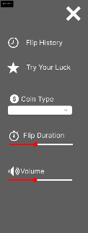

This is the menu, the names and its content is subject to change, things might get removed or added in the making of the app. The menus will look slightly different based on the page the user is currently on.

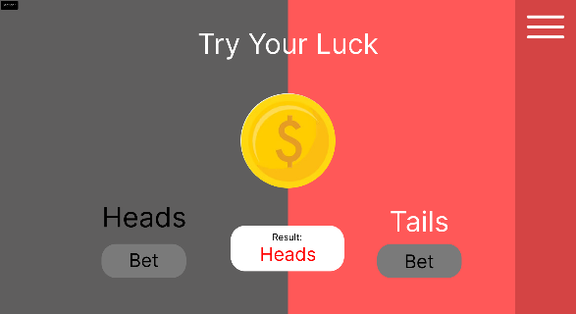

This is the design for the guess mode, the heading is subject to change and is most likely to be changed in the making of the app, again the same approach, keep it nice and simple.

# Interaction Design

This similar looking to a site map design shows the interactions between different elements of the app. Highlighted in red is the text that gives a rough idea of what will be going on behind the visuals in the app, in the code. Arrows point to different parts of the app; the dashed arrow is just there to keep things less clustered and easy to read.